WEEK 2 TASK: DATA VISUALIZATION AND REPORTING IN AGRIBUSINESS
Project Title: Agribusiness Data Visualization and Reporting Using Crop Data
Submitted by: Pooja Methre
Project Domain: Data Analytics – Agribusiness
Tools: Python, Google Colab, Pandas, Matplotlib, Seaborn, Microsoft Word, and GitHub

1. Introduction
Agribusiness plays an important role in agricultural production, food supply, employment, and economic development. Agricultural datasets contain useful information about crops, production, yield, geographical regions, and changes over time. However, raw data is often difficult to understand without proper organization and visualization.
Data visualization converts numerical and categorical information into charts, graphs, and tables that make patterns easier to identify. It helps analysts compare agricultural performance, recognize trends, detect unusual values, and communicate findings to decision-makers.
This project presents a data visualization strategy for agribusiness data using the crop.csv dataset. The project focuses on inspecting the available data, identifying relevant metrics, selecting suitable visualization techniques, and designing a structured report.
The report also describes the tools, design principles, workflow, potential challenges, mitigation strategies, and project timeline required to develop an effective agricultural data visualization report.
2. Project Objectives
The main objective is to develop a clear and practical strategy for visualizing agribusiness data.
The specific objectives are:
- Understand the structure and quality of the agricultural dataset.
- Identify relevant metrics based on the available columns.
- Select suitable charts, graphs, and tables for different analytical purposes.
- Compare crop categories and examine the distribution of numerical values.
- Explore trends over time and relationships between variables when the required data is available.
- Present statistical summaries in a clear and understandable format.
- Develop a logical report layout and project workflow diagram.
- Identify visualization challenges and propose appropriate solutions.
- Create a report that communicates findings accurately and supports data-driven agricultural decisions.
3. Dataset Overview
The project uses a CSV dataset named crop.csv, which is loaded and analyzed using Google Colab and Python.
The dataset will be examined to identify its columns, data types, number of records, missing values, duplicate rows, and statistical characteristics.
The actual dataset details will be recorded after inspection.
Dataset property | Details
Dataset name | crop.csv
File format | CSV
Analysis environment | Google Colab
Data processing library | Pandas
Visualization libraries | Matplotlib and Seaborn
Number of records | 169841
Number of columns | 7
Missing values | 2,933
Duplicate records | 0
The available variables will determine which agricultural metrics can be analyzed. Metrics such as crop production, yield, year, crop category, and region will be used only if the corresponding information exists in the dataset.
4. Data Inspection and Preparation
Before creating visualizations, the dataset must be inspected to understand its structure and identify possible quality issues.
4.1 Data inspection
The initial inspection includes:
- Displaying the first few rows.
- Checking the number of rows and columns.
- Listing all column names.
- Identifying numeric and categorical variables.
- Checking the data types of each column.
- Calculating summary statistics.
- Identifying missing values and duplicate records.
Python's Pandas library will be used for these operations.
4.2 Data preparation
The following preparation activities will be considered:
- Missing values: Identify incomplete records and decide whether to retain, remove, or appropriately fill missing values.
- Duplicate records: Check for repeated rows and remove them only when they represent genuine duplicates.
- Data types: Convert dates, years, and numeric fields to suitable data types where necessary.
- Inconsistent categories: Standardize category labels where spelling or formatting differences are found.
- Unusual values: Investigate unexpected negative values, extreme observations, or inconsistent measurements.
- Validation: Check that calculations and aggregated values are consistent with the underlying data.
Data preparation is important because incorrect values or inconsistent categories can lead to misleading visualizations.
No changes will be made automatically without checking whether they are appropriate for the dataset.
5. Identification of Agribusiness Metrics
The choice of metrics determines what the visualizations will communicate.
The following metrics are potential candidates, depending on the available dataset columns.
Metric | Description | Analytical purpose
Crop production | Quantity of agricultural output | Compare production levels
Crop yield | Agricultural output per unit of land | Compare productivity
Year or date | Time period associated with a record | Examine changes over time
Crop category | Type or category of crop | Compare crop groups
Region or state | Geographical location | Compare agricultural performance by location
Revenue | Income generated from agricultural sales | Examine financial performance, if available
Rainfall or temperature | Weather-related measurements | Explore possible weather and crop relationships, if available
The final selection will be based on the actual columns in crop.csv. Metrics that are not available will not be treated as observed data.
The purpose of this step is to ensure that each chart answers a meaningful agricultural question.
6. Visualization Strategy
The visualization strategy is designed to make agricultural data easier to compare, interpret, and communicate.
Each visualization will be selected according to the type of data and the question being investigated.
6.1 Bar chart
Purpose: Compare values across different categories.
A bar chart can compare average crop-related measurements across crop types or other categories.
Design approach:
- Place categories on the horizontal axis.
- Place the selected numeric metric on the vertical axis.
- Sort categories when this improves readability.
- Use clear axis labels and an informative title.
- Limit the number of displayed categories when there are too many to read comfortably.
Expected use: Identify categories with relatively high or low average values.
Interpretation: The chart will be used to compare category averages. Conclusions will be based on the actual plotted results.
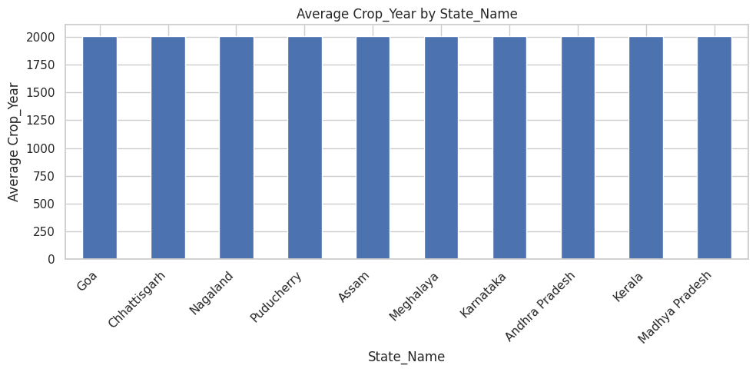

6.2 Histogram
Purpose: Understand the distribution of a numeric variable.
A histogram groups numerical observations into intervals and displays how frequently values occur in each interval.
Design approach:
- Select a meaningful numeric variable.
- Choose an appropriate number of bins.
- Label the horizontal axis with the variable name and units, where known.
- Label the vertical axis as frequency or count.
- Avoid unnecessary visual decoration.
Expected use: Identify common value ranges, spread, skewness, and possible extreme observations.
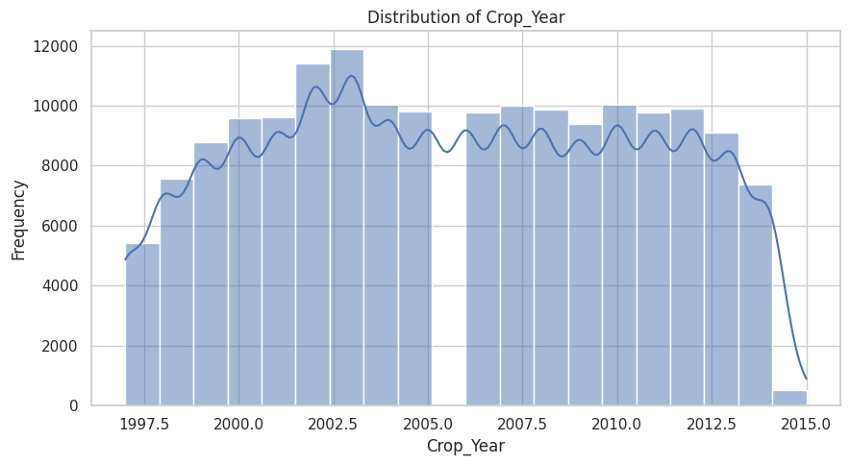

6.3 Line graph
Purpose: Examine changes in a metric over time.
A line graph is suitable when the dataset contains a meaningful year, date, or time variable.
Design approach:
- Place the time variable on the horizontal axis.
- Place the measured metric on the vertical axis.
- Aggregate records consistently when multiple observations exist for the same period.
- Maintain chronological ordering.
- Use markers when they improve readability.
Expected use: Identify increases, decreases, fluctuations, and possible long-term patterns.
If the dataset does not contain a suitable time variable, a line graph will not be forced into the report. An alternative visualization will be selected.
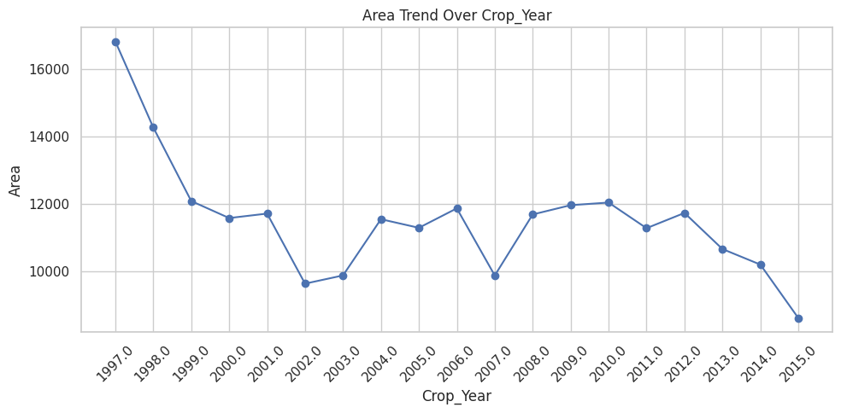

6.4 Scatter plot
Purpose: Explore the relationship between two numeric variables.
A scatter plot represents each observation as a point based on its values for two variables.
Design approach:
- Select two meaningful numeric variables.
- Label both axes clearly.
- Use an appropriate scale.
- Investigate visible patterns, clusters, and unusual observations.
Expected use: Examine whether the selected variables appear to move together or show a possible association.
A visible association does not prove causation. Additional analysis would be required to establish whether one variable influences another.
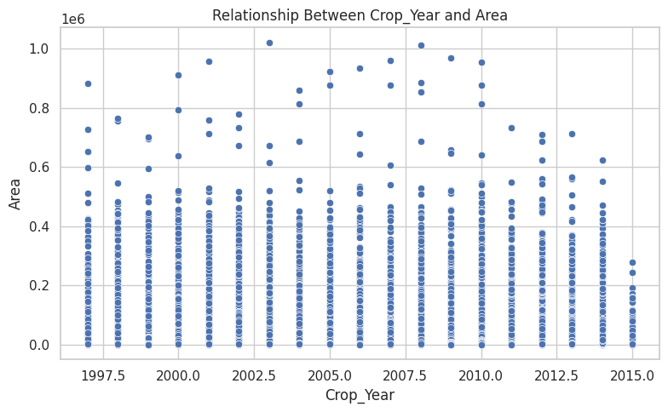

6.5 Summary statistics table
Purpose: Present exact statistical values in a compact format.
The table may include:
- Count of available observations.
- Mean.
- Median.
- Minimum.
- Maximum.
- Standard deviation.
Expected use: Support chart interpretation with numerical information and help readers understand the scale and distribution of the data.
The statistics will be calculated only for relevant numeric columns.
 | Count | Mean | Median | Minimum | Maximum | Std. Deviation
Crop_Year | 169840.0 | 2005.68 | 2006.00 | 1997.00 | 2.015000e+03 | 4.92
Area | 169840.0 | 11470.69 | 600.00 | 0.04 | 1.020181e+06 | 38035.50
Production | 166914.0 | 741846.91 | 728.55 | 0.00 | 1.125000e+09 | 19675874.22

7. Recommended Visualization Tools and Techniques
7.1 Python
Python will be used for data processing, statistical calculations, and visualization. It supports repeatable analysis and can handle structured datasets efficiently.
7.2 Google Colab
Google Colab provides a browser-based Python environment. It allows the dataset to be loaded, code to be executed, and charts to be generated without requiring a local Python installation.
7.3 Pandas
Pandas will be used to:
- Load the CSV dataset.
- Inspect column names and data types.
- Identify missing and duplicate records.
- Group data by categories.
- Calculate summary statistics.
- Prepare aggregated datasets for charts.
7.4 Matplotlib
Matplotlib will be used to create and customize charts, including bar charts and line graphs. It provides control over chart titles, labels, figure sizes, and image exports.
7.5 Seaborn
Seaborn will be used to create statistical visualizations such as histograms and scatter plots. It also supports consistent chart styling.
7.6 Microsoft Word
Microsoft Word will be used to prepare the final report. It will contain the project explanation, visualization strategy, conceptual chart examples, workflow diagram, storyboard, challenges, mitigation strategies, and timeline.
7.7 GitHub
GitHub will be used to maintain the project files and make the technical work accessible for review. The repository will contain the notebook, dataset where sharing is permitted, and the final report or supporting project documentation.
8. Visualization Design Principles
An effective visualization should be accurate, readable, consistent, and appropriate for its intended audience.
8.1 Clarity
Each chart will have a meaningful title, clearly labeled axes, and understandable units. Unnecessary decoration and excessive text will be avoided.
8.2 Consistency
Similar chart types will use consistent fonts, formatting, and visual styles. Colors will be used consistently to distinguish categories or highlight important information.
8.3 Appropriate chart selection
Charts will be selected according to the analytical question. Bar charts will be used for category comparisons, histograms for distributions, line graphs for time trends, and scatter plots for relationships between numeric variables.
8.4 Accuracy
Axes, scales, aggregation methods, and labels will be checked to ensure that the visual representation accurately reflects the data. Missing values and exclusions will be documented where relevant.
8.5 Readability
Chart sizes, fonts, and labels will be adjusted to make the figures readable on a computer screen and in the final Word document.
8.6 Scalability
The visualization process will be designed so that it can be repeated when additional records or new reporting periods become available. Reusable Python code and consistent data-processing steps will make future updates easier.
8.7 Accessibility
Color combinations will be chosen to maintain sufficient contrast. Important information will also be communicated through labels and chart structure rather than color alone.
9. Conceptual Chart Sketches
The following sketches illustrate the intended structure of the visualizations. They are conceptual examples, not actual results from crop.csv.
9.1 Conceptual bar chart
Title: Average Agricultural Metric by Category
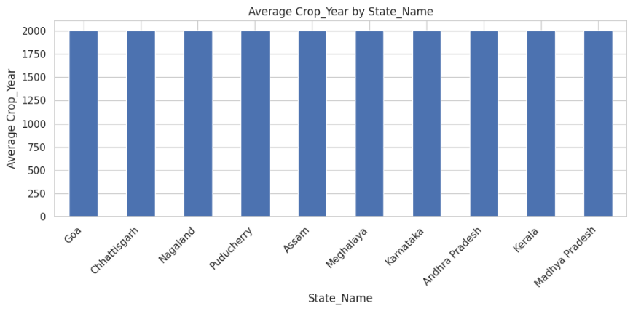

Explanation: Each bar represents the average value for a category. The chart makes comparisons between categories easier.
The actual categories, values, title, and units will be taken from the dataset.
9.2 Conceptual histogram
Title: Distribution of an Agricultural Metric

Explanation: The histogram illustrates how numerical observations may be distributed across different ranges. The actual shape will depend on the dataset.
9.3 Conceptual line graph
Title: Agricultural Metric Over Time

Explanation: A line graph connects values in chronological order to show how a metric changes over time. This chart will be included only if suitable time data exists.
9.4 Conceptual scatter plot
Title: Relationship Between Two Numeric Variables
Explanation: Each point represents an observation. The plot helps identify possible relationships, clusters, and unusual values without assuming that one variable causes another.
10. Report Storyboard and Layout Plan
The storyboard defines the order of the report sections and explains how the reader will move from the dataset overview to the final recommendations.
Order | Report section | Content | Purpose
1 | Title page | Project title, student name, project domain | Introduce the project
2 | Introduction | Background and objectives | Establish the purpose
3 | Dataset overview | Dataset size, variables, and data types | Explain the available data
4 | Data preparation | Missing values, duplicates, and validation | Describe data quality
5 | Metrics | Selected agricultural measures | Define the analysis
6 | Visualization strategy | Chart choices and justifications | Explain the analytical approach
7 | Visual analysis | Actual charts and captions | Present visual evidence
8 | Summary table | Descriptive statistics | Support interpretation
9 | Findings and recommendations | Evidence-based insights | Connect analysis to decisions
10 | Design principles | Clarity, consistency, and accessibility | Explain design quality
11 | Workflow diagram | Project stages from data to submission | Show the process
12 | Challenges and mitigation | Risks and proposed solutions | Demonstrate problem-solving
13 | Timeline | Activities and estimated duration | Establish a work plan
14 | Conclusion | Summary and future improvements | Close the report
The final report will place charts close to their explanations so readers can understand the findings without searching through different sections.
11. Project Workflow Diagram
The workflow represents the sequence of activities required to complete the visualization project.
START

Load Agribusiness Dataset

Inspect Columns and Data Types

Check Missing Values and Duplicates

Prepare and Validate Data

Identify Key Metrics

Select Appropriate Visualization Techniques

Create Charts and Summary Tables

Interpret Results and Identify Insights

Design Report Layout and Storyboard

Review Challenges and Validate Findings

Prepare Final Word Report

Upload Project Files to GitHub

Submit and Review

END

Workflow explanation
The process begins by loading the dataset into Google Colab and examining its structure. The data is then checked for missing values, duplicates, incorrect data types, and unusual observations.
After preparation, the relevant metrics are identified and matched with suitable visualization techniques. Charts and summary statistics are generated, and the results are reviewed to identify meaningful patterns.
The findings are then organized into a structured report containing charts, explanations, the storyboard, workflow, challenges, and recommendations. Finally, the report and supporting technical files are reviewed before submission.
12. Potential Challenges and Mitigation Strategies
Data visualization projects may encounter problems related to data quality, chart selection, interpretation, and presentation. Identifying these challenges in advance improves the reliability of the final report.
Potential challenge | Possible impact | Mitigation strategy
Missing values | Incomplete analysis or misleading summaries | Measure missingness and select a suitable treatment based on the variable and context
Duplicate records | Some observations may be counted more than once | Identify duplicates and verify whether they represent repeated records before removal
Inconsistent category names | Similar categories may appear as separate groups | Standardize labels after checking their meaning
Incorrect data types | Calculations or chronological ordering may fail | Convert variables to suitable data types and validate the result
Unusual values | Extreme observations may distort scales or averages | Investigate unusual values and retain valid observations rather than deleting them automatically
Too many categories | Charts may become crowded and difficult to read | Sort categories, show a relevant subset, or use a suitable alternative layout
Inappropriate chart selection | The visualization may not answer the intended question | Match the chart to the data type and analytical objective
Misleading scales | Differences may appear larger or smaller than they are | Use appropriate axis ranges and clearly label scales
Missing time information | Trends over time cannot be evaluated reliably | Use a different visualization or obtain suitable time-based data
Confusing chart design | Readers may misunderstand the findings | Use informative titles, readable labels, consistent formatting, and accessible colors
Incorrect interpretation | Unsupported conclusions may affect decisions | Verify claims against the actual values and distinguish association from causation
Large datasets | Visualizations may become slow or cluttered | Use appropriate aggregation and sampling where analytically justified
File or version problems | The submitted project may not match the final report | Use clear filenames and review the final notebook and report before submission
These strategies are intended to reduce errors and improve the clarity, reliability, and usefulness of the visualizations.
13. Design Validation and Quality Assurance
Before the report is finalized, each visualization will be reviewed against a quality checklist.
- Confirm that the chart uses the intended dataset and variables.
- Verify calculations and aggregation methods.
- Check that the title accurately describes the visualization.
- Ensure that both axes have meaningful labels and units where available.
- Confirm that categories and time periods are ordered appropriately.
- Review missing values and exclusions that may affect interpretation.
- Check that text, labels, and legends are readable.
- Ensure that colors and formatting remain consistent across charts.
- Confirm that each stated finding is supported by the displayed data.
- Verify that charts and tables are placed correctly in the Word document.
This validation process helps prevent misleading visuals and improves the quality of the final report.
14. Project Timeline
The following timeline is a proposed schedule for completing the visualization project.
Day | Activity | Expected output
Day 1 | Inspect the dataset and define project objectives | Dataset overview and objectives
Day 2 | Check data quality and prepare variables | Prepared dataset and quality notes
Day 3 | Identify metrics and select visualization techniques | Visualization plan
Day 4 | Create appropriate charts and summary statistics | Charts and statistical table
Day 5 | Interpret results and organize the storyboard | Findings and report layout
Day 6 | Complete the workflow, challenges, and design sections | Complete report content
Day 7 | Review formatting, verify files, and submit | Final Word report and GitHub project
The schedule can be adjusted according to the complexity of the dataset and the time available.
15. Expected Outcomes
The project is expected to produce a structured visualization plan that explains how agribusiness data can be converted into understandable visual information.
The expected outcomes include:
- A documented overview of the dataset and its relevant metrics.
- A justified selection of suitable charts and graphs.
- Visualizations that support category comparisons, distribution analysis, and other relevant investigations.
- A summary table containing descriptive statistics.
- A report storyboard that organizes information logically.
- A workflow diagram describing the project process.
- A documented set of challenges and mitigation strategies.
- A consistent design approach that supports clarity, readability, and accessibility.
- A repeatable workflow that can be adapted to future agricultural datasets.
The report is intended to demonstrate how visualization planning supports effective data communication. Actual analytical conclusions will be based on the results obtained from the dataset rather than assumed in advance.
16. Recommendations for Agribusiness Decision-Making
Appropriate visualizations can help agricultural stakeholders understand differences in production, productivity, and other available metrics.
Based on the variables available, the report may support the following uses:
- Comparing agricultural categories to identify differences in performance.
- Monitoring changes over time when historical data is available.
- Examining distributions to understand variability in agricultural measurements.
- Investigating relationships between numerical variables.
- Communicating summary statistics to agricultural planners and other stakeholders.
- Identifying areas that may require additional investigation or better data collection.
Any operational recommendation will be made only after examining the actual results. Additional information may be necessary before using these findings to make production, investment, or resource-allocation decisions.
17. Conclusion
This project presents a structured approach to data visualization and reporting in agribusiness. It explains how to inspect agricultural data, identify meaningful metrics, select appropriate visualizations, and communicate results through a well-organized report.
The strategy combines Python-based data analysis with charts, descriptive statistics, design principles, and a clear reporting structure. It also considers challenges such as missing values, duplicate records, inappropriate chart selection, and misleading interpretation.
The inclusion of a workflow diagram, report storyboard, mitigation strategies, and project timeline provides a clearer explanation of how the project will be planned and completed.
Overall, effective data visualization can make agricultural information easier to understand and support better-informed decisions. The usefulness of the final report will depend on the quality of the underlying data, the appropriateness of the visualizations, and the accuracy of the conclusions drawn from the analysis.
18. References and Tools
The following tools and documentation resources support the proposed workflow:
- Python: https://www.python.org/
- Google Colab: https://colab.research.google.com/
- Pandas documentation: https://pandas.pydata.org/docs/
- Matplotlib documentation: https://matplotlib.org/stable/
- Seaborn documentation: https://seaborn.pydata.org/
- Microsoft Word: https://www.microsoft.com/microsoft-365/word
- GitHub: https://github.com/
These resources provide documentation for data processing, chart creation, report preparation, and project version control.

